Manytide Player and Instructor Manual
Created by Yoav Duman
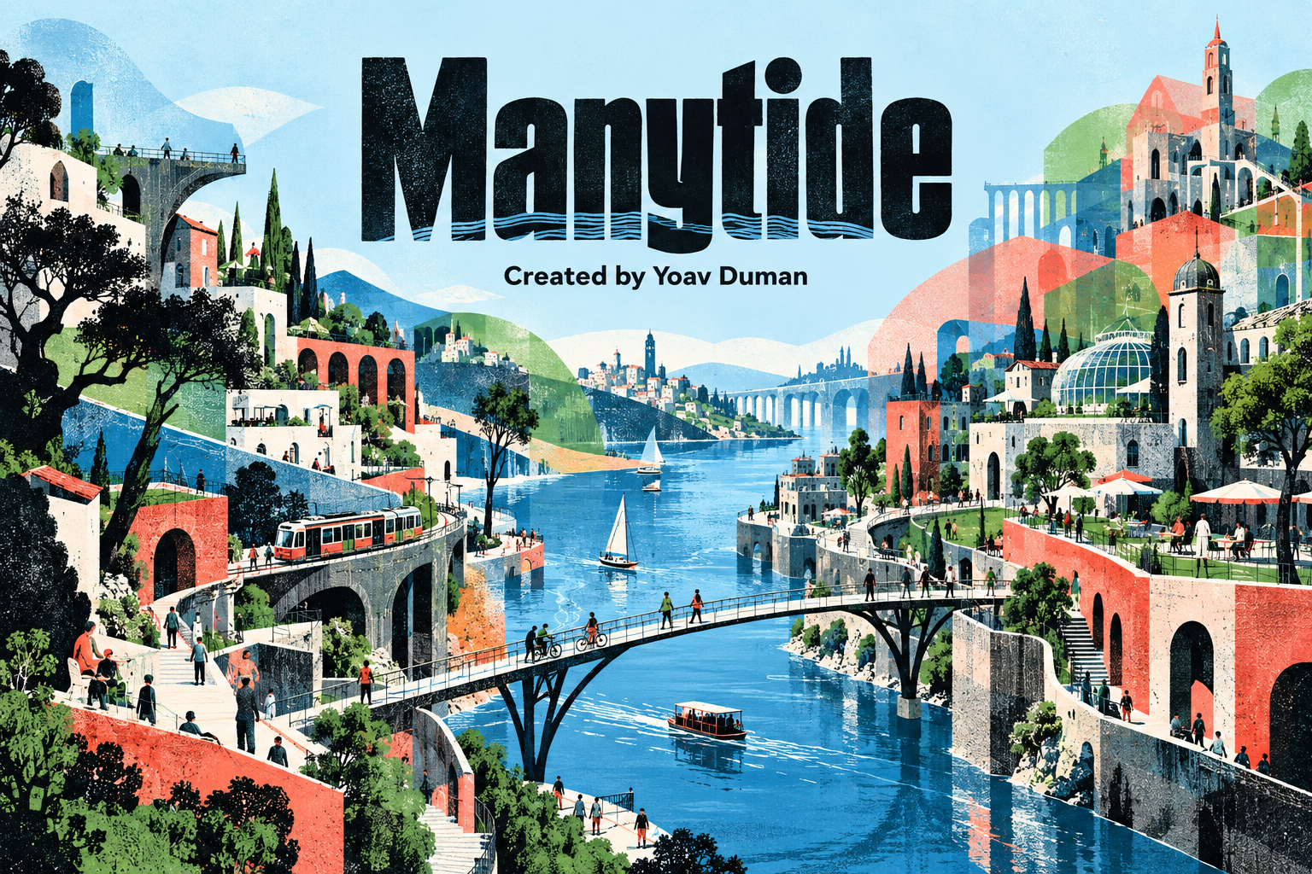
Follow a public-systems mission through the fictional country of Veyra. Your task is to recommend arrangements, commission lawful work and explain what your evidence can support. People already live here; your choices concern how institutions deal with their overlapping lives and attachments.
Version 2 · story edition 2026-10-10.3 · suggested core 45–60 minutes · optional extra case about 10 minutes · individual play · no student account required
Open Manytide on yoavduman.com

Start here
Open the simulation and choose a 45, 55 or 60 minute guide. These are pacing suggestions, not a countdown. Add a name or alias and class section if your instructor wants them on your printout. Choose Start the route, record your initial interpretation and open the first folder. You do not need to know nationalism theory before beginning.

Follow the route

Five stops with different problems
The stop that disappeared examines categories and destinations. Two shores, one shift asks whether a connection delivers usable access. The river does not belong to the timetable introduces overlapping authority and treaty jurisdiction. A border can move without a house moving tests constitutional arrangements and internal minorities. Money arrives with a map returns to finance, staffing and accountability. Each stop adds a duty to the route; a later decision does not erase earlier obligations.

Make a decision you can explain
Read the scene and records. Choose an institutional arrangement, inspect who can authorize it, and decide whether to fund one optional implementation bundle. Work units measure commissioning effort; they do not price people or rights. The interface shows the cost and available units. At most two unused units may carry into the next core stop. More spending is not a winning strategy: inspect what the work does and what remains unresolved.

Link evidence before the result
Use Use as evidence on a relevant record. Write a prediction and an explanation of an unresolved concern or condition, then select Record the decision. A useful prediction names who is affected, what might change and how the record supports that expectation. Suggested lengths are guidance. Concise, reasoned answers are welcome. The app preserves your first prediction; it does not understand or grade your prose.

Read what your choice actually changed
The result combines the base observation with the work you funded. Inspect authorization limits, the affected person's return note and the duty still to do. Compare it with your original forecast. River and compact reflections ask you to reconsider particular implications. Use Map & commitments to distinguish routes, jurisdictions and delivery; these diagrams are schematic public relationships, not an ethnic population map.

Compare and explain
After the five stops, select a different compact under the same staff, earlier duties and fiscal stress. Your chosen finance context stays fixed in both arrangements. Explain a mechanism that changes and a constraint that remains. The five-kind distinction table is available to open when you need it. Apply your reasoning to an unfamiliar fictional setting, then complete the final debrief. Address what changed, a rival explanation or missing observation, and what sovereign separation would leave unresolved. Supporting, rejecting or qualifying separation can all be defensible; explain the conditions.

Keep your work

Saving and returning
Progress saves in this browser on this device. Watch the saved-status message. Pause the journey to return to the home screen, then use Resume saved run or Saved runs. Private browsing, cleared site data and another browser can remove access to a local save. Download a backup before leaving an important session. If a message reports storage trouble or a newer copy in another tab, preserve a backup of your current edits before reloading.

A backup and a report serve different purposes
Save in the top bar and Save backup at completion download a JSON progress file. This is the file for resuming or moving devices. Restore a backup opens a preview; check the name, edition and progress before confirming Restore this run. A restored run keeps its original story package. A TXT record or PDF is readable work to submit, not a resumable backup.

Print and submit
At completion, Print core / save PDF opens your browser's print dialog. Choose a printer or the device's PDF option. Text record downloads the readable journal; Save backup protects resumable progress. Your report includes original expectations, choices, linked records, observations, revisions, comparison and debrief. Review the scope and content before sharing. Nothing automatically submits to Canvas. Upload the requested file or photograph yourself.

The optional coastal detour
The core is complete before the invitation appears. Start extra case adds about ten minutes in a coastal setting, testing changing demand and which institutional ideas travel. The detour has its own six work units and no core carry-in. Read, choose, forecast, observe and answer its revision and comparison prompts. Finish here leaves the core complete. An unfinished detour remains resumable; a completed detour can be printed alone or with the core using Print both.

Reading and listening
Settings offers text-size, focus and motion controls. Read aloud starts from the current learning stage; Pause reading, Resume reading and Stop reading control playback. Voice availability depends on the browser. The written records remain available if speech is unsupported. Terms, evidence and the expanded map provide another route into a difficult passage.

Use Manytide in a class

The learning task
Use this before or alongside an introduction to nationalism. Students should distinguish residence, administrative categories, public access, jurisdiction and national identification. Ask them to connect authority with implementation capacity, recognize minorities inside a proposed autonomous unit and identify obligations that cross a new border. Treat the fictional outcomes as authored situations for reasoning, not empirical estimates of how real ethnic groups behave.

Prepare the assignment
Open a new v2 run on the device students will use. Try saving, restoring a JSON file, listening and the browser print dialog. Specify whether students submit the core only or may add the optional detour, and whether you want a PDF, TXT file or photograph. Encourage aliases where appropriate. One individual record per student makes reasoning visible; pairs can discuss while each keeps their own record. Offer additional time or an alternate reading format when needed.

Plan the session
A 55 minute core guide allocates four minutes to the opening; 5, 7, 7, 8 and 7 minutes to the five stops; two minutes to the matched comparison; four to transfer; eight to debrief; and three to export. Use the 45 or 60 minute guide when it better fits the class. These budgets are suggestions, not observed student completion times. If discussion is part of a 50 minute class, begin the route before class or finish the debrief and export afterward. Keep the optional ten minutes outside the core budget.

Facilitate without supplying the policy
At the river, ask who can authorize work and who must agree. At the compact, ask whose rights continue if a border changes. At finance, ask what a legal rule can do without staff or reliable funding. Let students disagree about federalism or sovereignty. Request a mechanism and a warrant for a claim; do not reward a preferred institutional answer.

Example of reasoning
Weak: “This makes everyone united.” Stronger: “A staffed appeal could change a refusal for this cross-region household, if it can issue and enforce a remedy. The service record does not establish changed national attachment.” Either example can accompany different institutional choices; assess the warrant, not the preferred arrangement.
Criterion | Look for
Mechanism | A specific link from the arrangement to an outcome for a named person.
Evidence | A record interpreted in context, with a limit on what it can establish.
Institutional scope | Authority, capacity and continuing rights distinguished.
Alternatives | A rival explanation or condition that could change the advice.
Transfer | A mechanism applied to a new setting with its boundary stated.

Discuss and adapt

Questions after the route
Which category changed while the people stayed put? When did access depend on more than a route? Which arrangement needed consent or ratification outside your mandate? Did your evidence show changed service delivery, changed attachment, both, or neither? Who would still need protection after separation? Compare two students' compact choices under the same stress: where does authority differ and where does capacity remain a constraint?

A short follow up
Ask students to choose two stops and write a conditional claim: this arrangement could change this outcome if these actors can implement it. Then ask for one observation that would challenge the claim. Use the optional coast to ask whether residence, demand, political authority and identification move together. Avoid turning a schematic connection or service result into evidence of national loyalty.

Review reasoning rather than compliance
Completion records participation in the required tasks. It is not a measure of mastery, enjoyment or agreement with the instructor. Use the criteria on the previous page to review a short response. For stronger learning evidence, use an unfamiliar case before and after play; keep student interest and enjoyment questions separate from the quality of their argument.

Edition and instructor controls
This manual covers the fixed v2 website edition, 2026-10-10.3. The separate protected instructor studio supports draft content, publication and rollback. It requires an authorized identity and the instructor code. Studio releases apply to new runs on that hosted game; they do not silently replace the website edition or an existing student's pinned package. Preview an edited release and tell students which URL and edition to use. The website resource editor lets the owner manage the listing, cover and preparation notes.

Useful links
Open Manytide
Protected instructor studio
All comparative politics materials

About the artwork
The cover is an AI-created conceptual illustration of a connected fictional city. It depicts no measured population distribution. The title and Created by Yoav Duman credit should remain visible when the image is reused.

